Image | 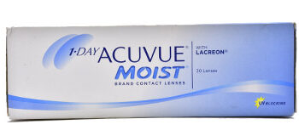
Brand | VERSACE
Model Name
Price
PRODUCT DETAILS

